

**TRAINING REPORT**

**OF**

**SUMMER TRAINING, UNDERTAKEN**

**AT**

**“EXCELLENCE TECHNOLOGY”**

**ON**

**“JAVA”**

**SUBMITTED IN PARTIAL FULFILLMENT OF THE DEGREE**

**OF**

**BACHELOR OF TECHNOLOGY**

**IN**

**Computer Science and Engineering**

**Submitted By:**

**Name: Preeti**

**Roll No: 12101037**

**DEPARTMENT OF COMPUTER SCIENCE & ENGINEERING**

**PUNJABI UNIVERSITY**

**PATIALA – 147002**

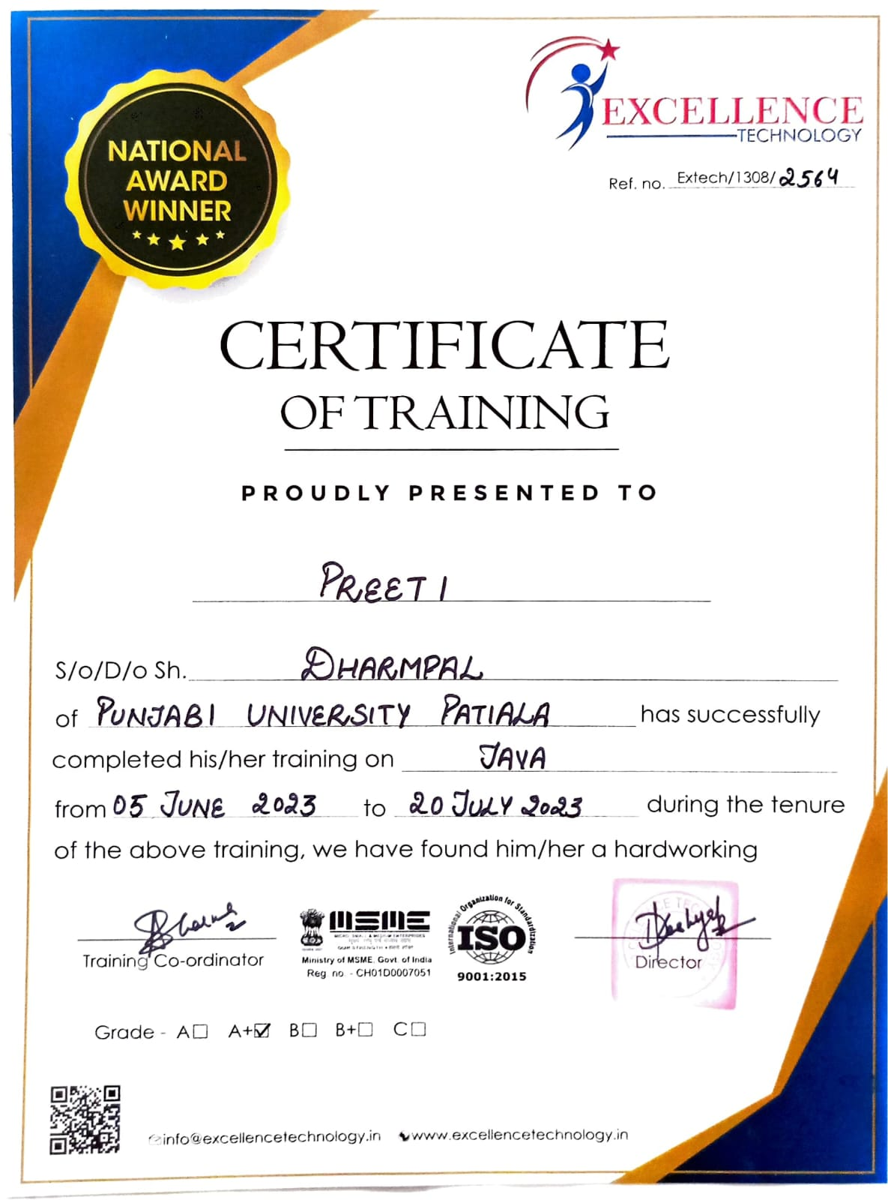

**DEPARTMENT OF COMPUTER SCIENCE & ENGINEERING PUNJABI UNIVERSITY, PATIALA**

# **CANDIDATE'S DECLARATION**

I “PREETI” hereby declare that I have undertaken Summer training at “Excellence technology, Mohali” during a period from 5th June 2023 to 20th July 2023 in

partial fulfillment of requirements for the award of degree of B.Tech (Department of Computer Science & Engineering) at Punjabi University, Patiala. The work which is being presented in the training report submitted to Department of Computer Science & Engineering) at Punjabi University, Patiala is an authentic record of training work.



Signature of the Student

The summer training Viva–Voce Examination of Java has been

held on and accepted.

Signature of Examiner

# **ABSTRACT**

Student Information Management System is software which is helpful for students as well as the school authorities. In the current system all the activities are done manually. It is very time consuming and costly.

Our Student Information Management System deals with the various operations related to the student’s information. In the Software student’s details are registered. Administrator has the power to add new student and can edit and delete a student and student can login with their id and print their details Hence the records are updated on databases too.

ABSTRACT

Student Management System is software which is helpful for students as well as the school

authorities. In the current system all the activities are done manually. Its time saving and

scalable. Our Student Management System deals with the various activities related to the

students

In the software we can register as a user and user has two types student and administrator.

Administrator has the power to add new user and can edit the students details entered. A

admin can add students record ,attendance status with department wise. All students can

search his/her basics details and attendance status with there respective roll numbers.

# **ACKNOWLEDGEMENT**

It is my pleasure to be indebted to various people, who directly or indirectly contributed in the development of this work and who influenced my thinking, behaviour and acts during the course of study.

I express my sincere gratitude to **DR. HIMANSHU AGGARWAL** worthy H.O.D for providing me an opportunity to undergo summer training at **Excellence Technology, Mohali*.***

I am thankful to our project guide **MR. DILIP SINGH** for his support, cooperation, and motivation provided to me during the training for constant inspiration, presence and blessings.

Lastly, I would like to thank the almighty and my parents for their moral support and our friends with whom I shared my day-to-day experience and received lots of suggestions about quality of work.

# **ABOUT THE COMPANY/INSTITUTE**

Excellence technology offers the best **Six/6 months industrial training in Chandigarh** for all engineering branches. After spending 3 and half years in college all you learn is the theoretical part. But life is all about practical. Your college or your curriculum gives you 6 months to learn things practically. and have an experience of the industry and learn what exactly the industry wants from you. So **Excellence Technology** gives you 100% practical training on live projects. Because 6/six months industrial training in Chandigarh can change your career. and make you to the part of best top reputed companies of India and globe. They have a team of professionals who work 24*7 to improve the quality education they are imparting among students.

Key Features of Excellence Technology :

* 100% practical training no theory.
* No white board or markers, screen based classes where you will learn more faster and more clearly.
* Special classes for those who believe that programming is not their cup of tea.
* one to one session, individual personalized classes .
* Create your profile on free lancing websites where you can start free lancing online.
* Conduct minimum 5 interviews in top reputed companies.
* Free web hosting and domain to live your project, which will help you to create a better portfolio.
* 3 Hours daily dedicated class.

# **LIST OF FIGURES**

**Figure 1.1 Working Diagram 1**

**Figure 2.1 Methodology DFD 15**

**Figure 2.2 ER Diagram Symbols 16**

**Figure 2.3 ER Diagram SIMS 17**

**Figure3.1 Index Page 18**

**Figure 3.2 Admin Login Page 19**

**Figure 3.3 Admin SignUp Page 19**

**Figure3.4 Admin Home Page 20**

**Figure3.5 Add Student Data Page 21**

**Figure 3.6 View Data Page 21**

**Figure 3.7 Edit student Page 22**

**Figure 3.8 Student Login Page 22**

**Figure 3.9 Student Information Page 23**

**Figure 3.10 Student database table 23**

**Figure 3.11 User database table 24**

# **INDEX**

|  |  |  |
| --- | --- | --- |
| **SERIAL NO.** | **TOPICS** | **PAGE NO.** |
| **1** | **INTRODUCTION** | **1-11** |
| 1.1 | Project Details | 1 |
| 1.2 | About SIMS | 1 |
| 1.3 | About Java | 2-4 |
| 1.4 | Technologies Used | 5-7 |
| 1.5 | Application and Server Used | 7-11 |
| **2** | **TRAINING AND WORK UNDERTAKEN** | **12-17** |
| 2.1 | Sequential learning steps | 12-13 |
| 2.2 | Methodology DFD | 13-15 |
| 2.3 | ER diagram | 16-17 |
| **3** | **RESULT AND DISCUSSION** | **18-24** |
| 3.1 | Snapshots of SIMS | 18-24 |
| **4** | **CONCLUSION AND FUTURE SCOPE** | **25-26** |
| 4.1 | Conclusion | 25 |
| 4.2 | Future Scope | 26 |
| **5** | **Reference** | **27** |

# **CHAPTER 1- INTRODUCTION**

## **PROJECT DETAILS**

* Title: Student Information Management System
* Platform: Advanced Java
* Front End languages: HTML, CSS, JAVA SCRIPT
* Back End Language: MySql

## **ABOUT SIMS (Student Information Management System)**

This project is developed in Advanced Java. Student Information Management System is about performing CRUD operations on student’s data. Administrator can create, read, update and delete a student’s information and student can login with their Id and print their details. Working of SIMS can be shown as follows:

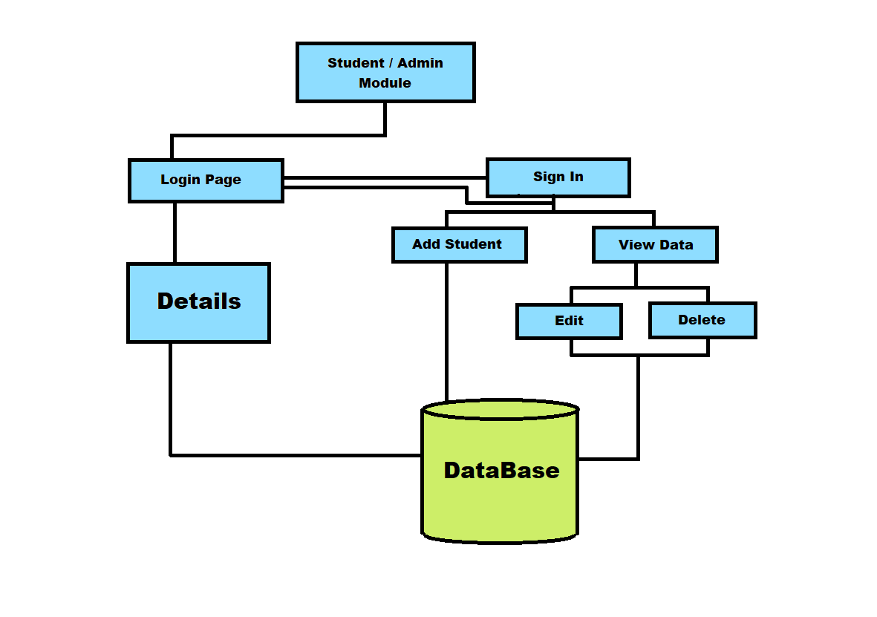

*Figure1.1 Working Diagram*

1

## **ABOUT JAVA**

JAVA is an object-oriented programming language developed by Sun Microsystems and it was released in 1995. James Gosling initially developed JAVA in Sun Microsystems (which was later merged with Oracle Corporation).

It is divided into two parts that is CORE Java and ADVANCE Java. Core Java is a Java standard edition (JSE) and the Advance Java is a Java enterprise edition (JEE).Core Java assists a user in building some general-purpose applications. But Advance Java help user in making web applications.

JAVA is a set of features of C and C++. It has obtained its format from C, and OOP features from C++. JAVA programs are platform independent which means they can be run on any operating system with any processor as long as the Java interpreter is available on another platform; it’s called write once, run anywhere (WORA).

Java Virtual Machine (JVM) executes Java code, but it has been written in platform specific languages such as C/C++/ASM, and Java interpreter is a part of JVM. JVM is used to convert byte code into machine code.

**1.3.1 FEATURES OF JAVA :**

* OBJECT-ORIENTED: Java support the features of object-oriented programming. Its

object model is simple and easy to expand.

* PLATEFORM INDEPENDENT: C and C++ are platform dependency languages

hence the application programs written in one operating system, but in platform

independence language like Java can be able to run on any operating system.

* SIMPLE: Java has include many features of C/C++, which makes it easy to

understand.

* SECURE: Java provides a wide range of protection from viruses and malicious

programs. It ensures that there will be no damage and no security will be broken.

* PORTABLE: Java provides us with the concept of probability. Running the same

program with Java on different platforms is possible.

2

* ROBUST: During the development of the program, it helps us to find possible

mistakes as soon as possible.

* MULTI-THREAD: The multi-threading programming feature in java allows you to

write a program that performs several different tasks simultaneously.

* DISTRIBUTED: Java is designed for distributed internet environments as it manages

the TCP/IP protocol.

* INTERPRETED: Java byte code is translated on the fly to native machine instructions

and is not stored anywhere. The development process is more rapid and analytical

since the linking is an incremental and light-weight process.

* DYNAMIC: Java is considered to be more dynamic than C or C++ since it is designed

to adapt to an evolving environment. Java programs can carry an extensive amount of

run-time information that can be used to verify and resolve access to objects at runtime.

* + 1. **JAVA DEVELOPMENT KIT**

The Java Development Kit (JDK) is a software package provided by Oracle (formerly Sun Microsystems) that includes tools, libraries, and executables necessary for developing and running Java applications. It's a crucial component for Java developers, as it provides everything needed to write, compile, and run Java programs. Here are some key points about the JDK:

* Components: The JDK consists of several components, including the Java compiler (javac), the Java Virtual Machine (JVM) that executes Java bytecode, development tools (like javadoc for generating documentation), and various libraries and APIs for different purposes.
* Versions: The JDK has gone through several versions over the years. Each version introduces new features, improvements, and sometimes changes to the language and libraries. Developers should select a JDK version that matches their project's requirements.
* JDK vs. JRE: The JDK is often confused with the Java Runtime Environment (JRE). While the JRE only includes the necessary components to run Java applications, the JDK also includes development tools needed to create, compile, and debug Java programs.

3

* Installing: To start developing Java applications, you need to install the JDK on your computer. The installation process varies based on your operating system. You can download the JDK installer from the official Oracle website or other distributions like OpenJDK.
* PATH Environment Variable: After installing the JDK, it's important to configure your system's PATH environment variable to include the location of the JDK's bin directory. This allows you to run Java-related commands (like javac, java, etc.) from any command prompt.
* Compiler: The javac command is used to compile Java source code (.java files) into bytecode (.class files), which can be executed by the JVM.
* Execution: The java command is used to execute Java applications. You provide the name of the class containing the main method, and the JVM launches the application.
* Development Tools: The JDK includes various tools to aid development, such as javadoc for generating API documentation, jdb for debugging, jar for creating and managing JAR files, and more.
* API Libraries: The JDK provides a standard library (Java Standard Library) that includes classes and packages for various functionalities like file I/O, networking, data structures, and more.
* Version Compatibility: It's important to ensure that the JDK version you're using to compile your code matches the version used in your deployment environment. Mismatches can lead to compatibility issues.
* OpenJDK: In addition to Oracle's JDK, there is also the open-source version of the JDK called OpenJDK. It serves as the base for various JDK distributions, including Oracle's JDK builds.
* Licensing: As of my last knowledge update in September 2021, Oracle JDK requires a subscription for commercial use and long-term support. OpenJDK builds are generally free to use. Be sure to check the latest licensing information from Oracle's official website.

The JDK is a crucial toolset for Java development, enabling programmers to write, compile, and run Java applications efficiently. Always ensure you're using a compatible JDK version for your project and consult the official documentation for the most up-to-date information.

4

## **TECHNOLOGIES USED**

* + 1. **JSP**

Java Server Pages (JSP) is a software technology. It is a server-side technology used for creating dynamic web pages in Java web development. JSP allows developers to embed Java code directly into HTML or XML pages, enabling the generation of dynamic content on the server before sending the final HTML page to the client's web browser.

JSP is processed on the server-side by a web server or application server that supports Java. When a client makes a request to a web application containing JSP files, the server processes the JSP files, executes the Java code embedded within them, and generates the dynamic content, which is then sent back to the client's browser as regular HTML.

The processing of JSP involves translating the JSP files into servlets, and these servlets handle the dynamic content generation. This allows developers to focus on writing Java code to handle dynamic aspects of the web application, such as database interactions, form processing, and other server-side operations.

In summary, JSP is a software technology used to build dynamic web applications in Java, and it runs on web servers or application servers that support Java Servlets and Java Server Pages.

* + 1. **HTML**

HTML is used in combination with Java technologies, such as Java Server Pages (JSP), to create the user interface and frontend of web applications. HTML (Hypertext Markup Language) is the standard language used to structure the content and layout of web pages. It defines the elements and their attributes that define the structure of the page.

HTML is the backbone of web pages in any advanced Java web application. It provides the structure and content presentation, while Java technologies handle the dynamic content generation, data processing, and business logic on the server-side. This combination enables developers to build powerful and interactive web applications.

* + 1. **CSS**

In advanced Java projects, CSS (Cascading Style Sheets) is used to enhance the visual appearance and layout of web pages. CSS is a style sheet language that defines how HTML

5

elements should be displayed on the screen, making it an essential part of frontend development in web applications. CSS is used in combination with HTML and Java technologies such as Java Server Pages (JSP), or other template engines to create visually appealing and responsive user interfaces.

CSS plays a critical role in creating a visually appealing and user-friendly frontend for advanced Java web applications. It complements the dynamic content generated by Java technologies, enabling developers to deliver polished and professional user interfaces

* + 1. **JAVA SERVLET API**

The Java Servlet API is a set of classes and interfaces that provide a standard way to handle HTTP requests and responses in Java web applications. Servlets are Java programs that run on a web server and handle incoming HTTP requests from clients (usually web browsers) and generate HTTP responses. The Servlet API allows developers to create dynamic web applications in Java.

* + 1. **MY SQL**

MySQL is a popular open-source relational database management system that is commonly used in advanced Java projects for storing, managing, and retrieving data. It is a crucial component in the backend of Java web applications, and it works seamlessly with Java technologies like Java Server Pages (JSP), Servlets, Spring, Hibernate, and more. Here's how MySQL is used in advanced Java projects:

* **Data Storage**: MySQL is used to store various types of data, including user information, application settings, transaction records, logs, and more. It provides a structured and organized way to persist data for web applications.
* **Java Database Connectivity (JDBC)**: JDBC is a Java API that enables Java applications to interact with databases, including MySQL. Developers use JDBC to connect to the MySQL database, execute SQL queries, and retrieve and manipulate data.
* **Database Security**: MySQL supports various security features, including user authentication, access control, and encryption of sensitive data. These features are essential for ensuring the security of the data stored in the database.

6

* + 1. **JDBC**

JDBC (Java Database Connectivity) is a critical technology in advanced Java projects for interacting with relational databases. It provides a standard API that allows Java applications to connect to a database, execute SQL queries, and manage data. JDBC is used extensively in combination with other Java technologies to build robust and scalable web applications.

JDBC is a fundamental technology for connecting Java applications to relational databases, making it possible to perform database operations and manage data effectively. It is a crucial part of the backend development in advanced Java projects that deal with persistent data storage and retrieval.

## **APPLICATIONS AND SERVER USED**

* + 1. **ECLIPSE IDE (Integrated Development Environment )**

Eclipse IDE is a powerful and widely used integrated development environment for Java and other programming languages. It is well-suited for advanced Java projects due to its extensive features and plugins that facilitate efficient and productive development. Here are some reasons why Eclipse IDE is commonly used for advanced Java projects:

* **Rich Java Development Features**: Eclipse provides comprehensive support for Java development, including code completion, syntax highlighting, code navigation, and refactoring tools. These features help developers write clean, reliable, and maintainable code.
* **Advanced Debugging**: Eclipse's debugging capabilities are robust and user-friendly. It allows developers to set breakpoints, inspect variables, and step through code, making it easier to identify and fix issues in Java applications.
* **Integrated Build System**: Eclipse integrates seamlessly with build automation tools like Apache Maven and Gradle. It allows developers to manage dependencies, build projects, and handle project configurations efficiently
* **Code Analysis and Quality Tools**: Eclipse supports various code analysis and quality tools, such as Check style, PMD, and Find Bugs.
* **Extensible Architecture**: Eclipse's plugin-based architecture allows developers to extend its functionality through various plugins. Many advanced Java frameworks and libraries offer Eclipse plugins for easier integration and development.

7

* + 1. **APACHE TOMCAT (RUNTIME SERVER)**

Apache Tomcat is often referred to as a "runtime server" because it provides a runtime environment for executing Java web applications. In the context of Java web development, the term "runtime" refers to the environment in which Java applications (such as Java Servlets and Java Server Pages) run and execute.

As a runtime server, Apache Tomcat serves as the Java Servlet Container, responsible for managing the execution of Java Servlets and other components of Java web applications. When a web application is deployed on Apache Tomcat, the server handles incoming HTTP requests, processes them through the appropriate Java Servlets and JSP pages, and generates dynamic content to be sent back to the client's web browser.

Here's how Apache Tomcat functions as a runtime server for Java web applications:

* + **Java Servlets**: Servlets are Java classes that handle HTTP requests and generate dynamic content for web applications. Apache Tomcat provides the environment in which these servlets are executed, ensuring that they can receive requests, process data, and generate responses.
  + **Java Server Pages (JSP)**: JSP is a technology that allows developers to embed Java code within HTML pages. When a JSP page is requested, Tomcat compiles it into a servlet, which is then executed to generate dynamic HTML content.
  + **Request Handling**: Apache Tomcat handles incoming HTTP requests from clients (usually web browsers), and based on the URL mappings defined in the web application's configuration, it forwards the requests to the appropriate servlets or JSP pages for processing.
  + **Lifecycle Management**: Tomcat manages the lifecycle of servlets, creating instances when needed and destroying them when they are no longer required. This ensures efficient memory utilization and proper handling of concurrent requests.
  + **Session Management**: Tomcat handles HTTP sessions, which allow web applications to maintain stateful interactions with clients. It manages session creation, tracking, and timeout, ensuring proper session handling across multiple requests.
  + **Context Management**: Tomcat supports multiple web applications simultaneously, and each application is referred to as a "context." It manages the contexts, loading and

unloading web applications as needed.

8

* + **Security and Access Control**: Tomcat provides security mechanisms for authentication and access control, allowing administrators to secure web applications and protect sensitive resources.

Overall, Apache Tomcat plays a vital role as a runtime server in Java web development. It provides the necessary infrastructure to execute Java Servlets and JSP pages, making it possible to build and deploy dynamic and interactive web applications written in Java.

* + 1. **MY SQL WORKBENCH**

MySQL Workbench is an official graphical tool provided by Oracle for working with MySQL databases. It offers a comprehensive set of features for database development, design, administration, and management. MySQL Workbench is widely used by database administrators, developers, and other professionals who work with MySQL databases. Here's an overview of MySQL Workbench:

* **Features:**
* **Database Design**: MySQL Workbench allows you to visually design and model database schemas using the Entity-Relationship Diagram (ERD) approach. You can create tables, define relationships, and set constraints within the visual designer.
* **SQL Querying**: The tool provides an SQL editor where you can write, execute, and analyze SQL queries against MySQL databases.
* **Query Visualization**: Query results are displayed in a grid format, making it easy to analyze and manipulate data.
* **Database Administration**: MySQL Workbench includes tools for managing server instances, user accounts, privileges, and server variables.
* **Performance Tuning**: It offers tools for performance optimization, including query profiling, database monitoring, and execution plan analysis.
* **Data Migration**: The Migration Wizard helps you migrate data from various sources to MySQL databases.
* **Backup and Restore**: MySQL Workbench facilitates database backup and restore operations, allowing you to create and manage backups.
* **Schema Synchronization**: You can compare and synchronize database schemas between different instances or versions.

9

* **Visual Explain**: This feature helps you understand and optimize complex SQL queries by visualizing their execution plans.
* **Database Utilities**: MySQL Workbench provides utilities for data import and export, server diagnostics, and managing server configuration files.
* **Scripting and Automation**: You can automate tasks by creating Python scripts using MySQL Workbench's scripting capabilities.
  + **Installation:**

MySQL Workbench is available for download from the official MySQL website. It supports Windows, macOS, and Linux platforms.

Once installed, you need to configure connections to your MySQL databases by providing connection details like hostname, port, username, and password.

* + **User Interface:**

The tool has a tabbed interface that allows you to work on multiple aspects of database development simultaneously.

It provides separate sections for schema design, SQL query editing, server administration, performance analysis, and more.

* + **Visual Database Design:**

The Entity-Relationship Diagram (ERD) editor lets you create, modify, and visualize the structure of your database using a graphical interface.

* + **Query Development**:

The SQL editor supports syntax highlighting, auto-completion, and query execution with result visualization.

* + **Community and Support:**

MySQL Workbench benefits from a large community of users and developers who provide support, plugins, and extensions.

The MySQL website offers documentation, tutorials, and resources to help users effectively utilize the tool.

10

* + **Integration:**

MySQL Workbench integrates with the MySQL server, allowing you to directly manage databases, users, and server settings.

MySQL Workbench is a powerful tool for MySQL database development and management, providing a user-friendly interface for a wide range of tasks from designing schemas to optimizing query performance. It's particularly valuable for those who prefer a visual approach to database-related activities.

11

# **CHAPTER 2-TRAINING WORK UNDERTAKEN**

## **2.1 SEQUENTIAL LEARNING STEPS**

Sequential learning steps for advanced Java involve gradually building upon foundational Java concepts and progressing to more sophisticated topics and technologies. Here is a suggested sequential learning path for mastering advanced Java:

* + 1. **Java Fundamentals**:
  + Start with basic Java concepts, including variables, data types, control structures (if-else, loops), arrays, and methods.
  + Understand object-oriented programming (OOP) principles like classes, objects, encapsulation, inheritance, and polymorphism.

**2.1.2 Java Collections Framework**:

* + Learn about the Java Collections Framework, which includes classes and interfaces for working with collections such as lists, sets, maps, and queues.

**2.1.3 Exception Handling**:

* + Study how to handle exceptions and errors effectively in Java applications.
    1. **File I/O**:
  + Explore input and output operations, including reading from and writing to files in Java.

**2.1.5 Multithreading and Concurrency**:

* + Understand multithreading concepts, synchronization, and concurrency in Java to develop applications that can handle multiple tasks simultaneously.

**2.1.6 Java Database Connectivity (JDBC)**:

* + Learn how to interact with databases using JDBC to perform database operations and manage data in Java applications.

12

* + 1. **Java Servlets**:
* Dive into Java Servlets, which are the foundation of Java web development, allowing you to build dynamic web applications.
  + 1. **Java Server Pages (JSP)**:
* Explore JSP, a technology that enables the integration of Java code into HTML to create dynamic web content.

## **2.2 METHODOLOGY DFD**

The methodology of developing a Student Information Management System involves a systematic and structured approach to design, develop, and implement the system. Here's a general outline of the methodology:

* + 1. **Requirement Analysis**:
  + Identify and gather the requirements for the Student Information Management System (SIMS) by consulting stakeholders, such as school administrators, teachers, and students.
  + Define the functional and non-functional requirements, including data management, user roles, reporting, and security.

**2.2.2 System Design**:

* + Create a detailed system design that outlines the architecture, database schema, user interface (UI) design, and data flow of the SIMS.
  + Decide on the technologies, programming languages, and frameworks to be used in the development.

**2.2.3 Database Design**:

* + Design the database schema to store student information.
  + Determine the relationships between different entities and set up appropriate data constraints.

13

* + 1. **User Interface Design**:
  + Design the user interface of the SIMS to be intuitive, user-friendly, and accessible for all stakeholders.
  + Ensure that the UI meets the specific needs of teachers, students, parents, and administrators.

**2.2.5 Development**:

* + Implement the SIMS based on the system design and database design.
  + Develop the core functionalities, such as student registration ,editing of records and deleting of records.

**2.2.6 Testing**:

* + Conduct rigorous testing to identify and fix any bugs or issues in the system.
  + Perform unit testing, integration testing, and user acceptance testing to ensure the SIMS functions correctly and meets the requirements.
    1. **Deployment**:
  + Deploy the SIMS on a server , making it accessible to users through web browsers or dedicated client applications.
  + Set up security measures, such as user authentication and role-based access control.

**2.2.8 Training and User Documentation**:

* + Provide training sessions for school staff and administrators to familiarize them with the SIMS functionalities.
  + Prepare user documentation, including user manuals and guides for easy reference.

**2.2.9 Maintenance and Support**:

* + Provide ongoing maintenance and support to address any issues or enhancements required after deployment.
  + Regularly update and improve the SIMS based on user feedback and changing requirements.

14

* + 1. **Data Backup and Security**:
  + Implement regular data backup procedures to ensure the safety and integrity of student information.
  + Ensure data security measures are in place to protect sensitive student data from unauthorized access.

**2.2.11 Continuous Improvement**:

* + Continuously gather feedback from users and stakeholders to identify areas for improvement and future enhancements.

The methodology ensures a well-organized development process, leading to the successful implementation of the Student Information Management System, which can efficiently manage student data and streamline administrative processes in educational institutions.

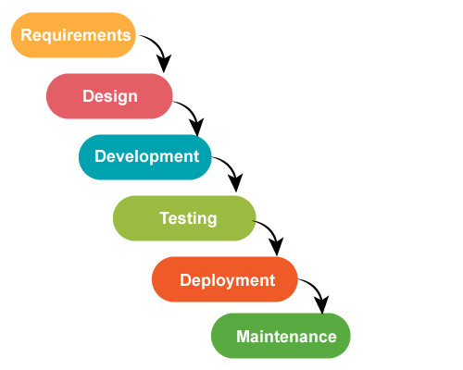

*Figure2.1Methodology DFD*

15

## **2.3 ER DIAGRAM**

E-R (Entity-Relationship) Diagram is used to represents the relationship between entities in a table. ER diagrams represent the logical structure of databases. ER Diagram represent relationship between two database tables.

E-R diagram means Entity Relationship diagram. Entity is a object of system, generally we refer entity as database table, the e-r diagram represent the relationship between each table of database. E-R diagram represent entity with attributes, attributes is a properties of entity. If we assume entity is a database table then all the columns of table are treat as attributes.

**Entity :** Entities are represented by **rectangle**. All table of database are treat as entity.

**Attributes :** Attributes are represented by **ellipses**. Attributes are properties of entities.

**Relationship :** Relationship are represented by **diamonds**. It depicts the relationship between two entities.

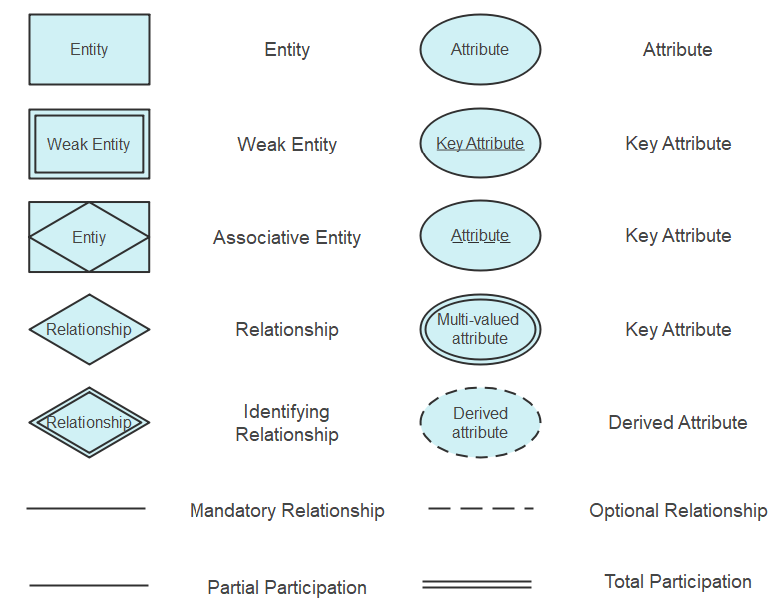

*Figure 2.2 ER Diagram Symbols*

16

**ER DIAGRAM FOR SIMS:**

In this ER Diagram Admin have two Many-To-One relation with the Admin Login Page, which means many admins can access to the admin login page and Admin Login Page have One-To-Many relation with Student which means one admin on admin Login page can add or view the data of a student from student data. Student have One-To-One relation with the student data which gives the idea that one student can login with his/her Id and can get his/her student data.

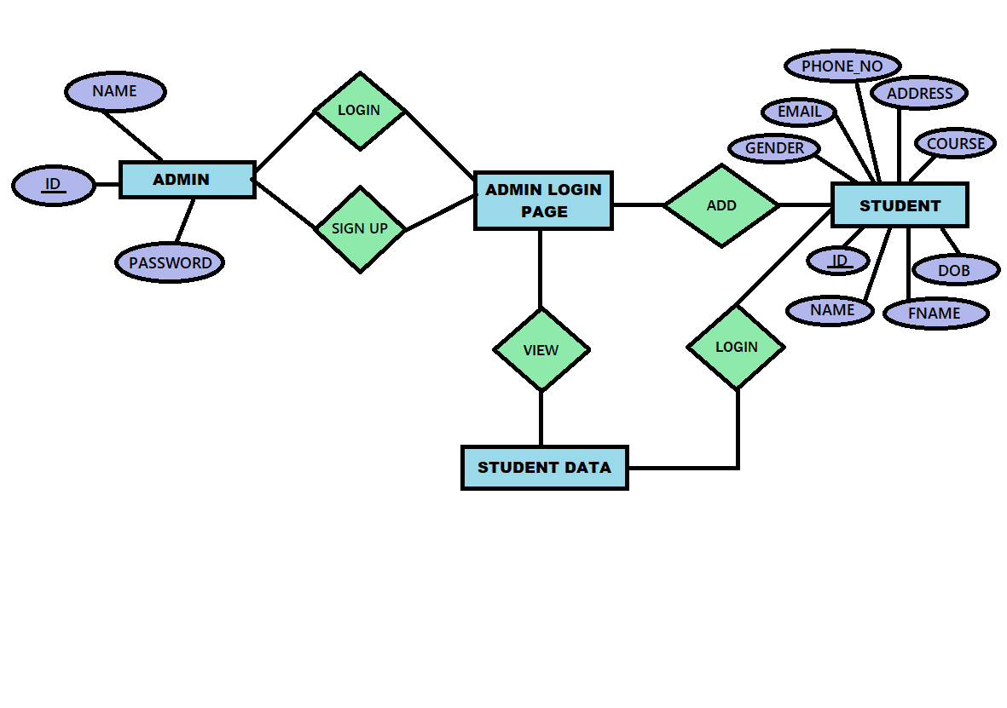

*Figure 2.3 SIMS ER Diagram*

17

# **CHAPTER 3 - RESULTS AND DISCUSSION**

Our Student Information Management System is useful both the Admin and Students .In this System Admin can Add ,delete, update and read the information about the student . hence it is easy to manage student records. meanwhile Students can also login with their Student_Id which is given by the admin and his/her email and can get the view of their information. Student is able to print their information too. As a result of this , it is very convenient for Admin and user to manage their records. Our system is very easy to use and have a basic design.   
Similar to the students, the teachers also become more productive with a student information management system.

## **SNAPSHOTS OF SIMS**

**3.1.1 INDEX PAGE :**

In the index page of SIMS we have two modules :

* + Admin Module
  + Student Module

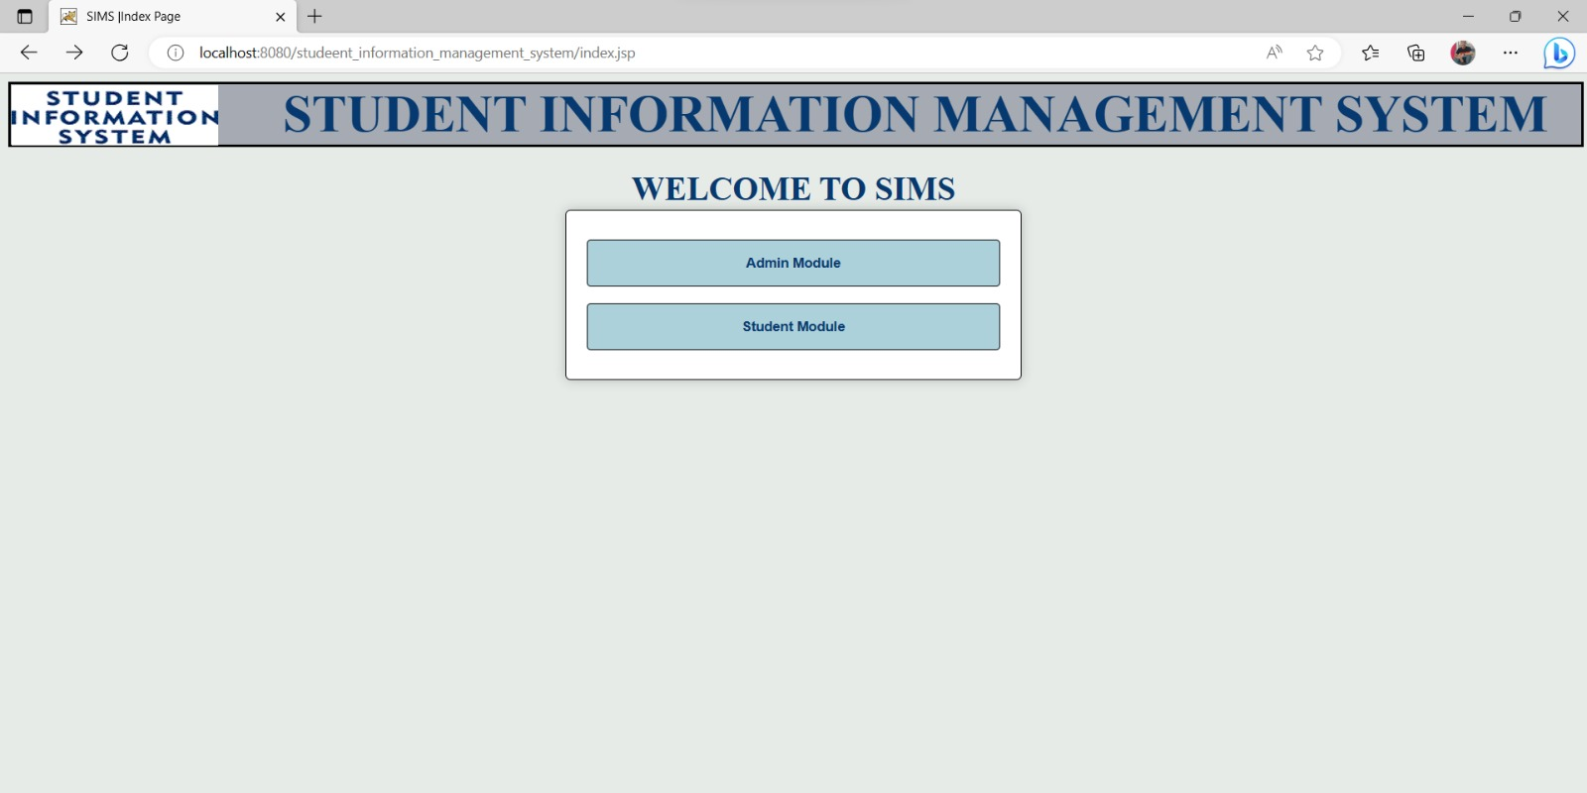

*Figure 3.1 Index page*

18

* + 1. **ADMIN LOGIN PAGE:**

In this page, if we are and admin we can directly login by filling our UserId and Password. But if we don’t have any userid then we can signup and create a new ID and login here.

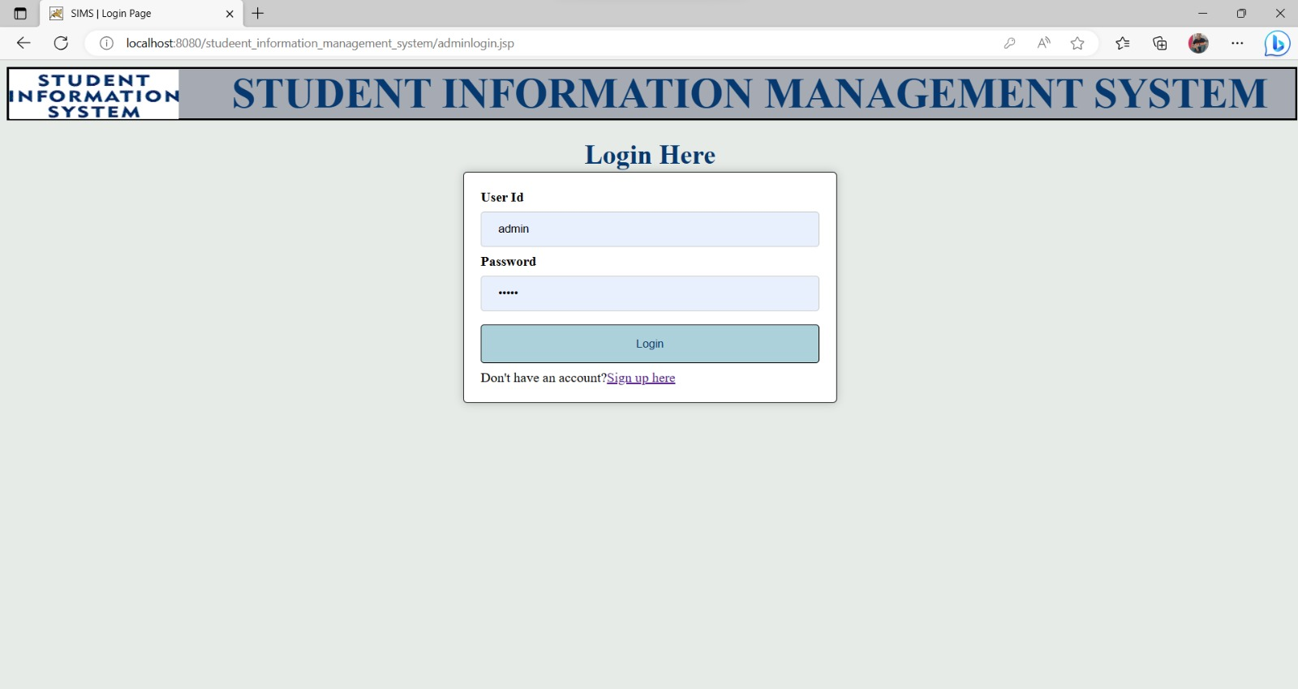

*Figure 3.2 Admin Login Page*

**3.1.3 ADMIN SIGNUP PAGE :**

In this page we can singup as new Admin by giving our UserId, UserName and Password. And then we can login to the Admin Login Page.

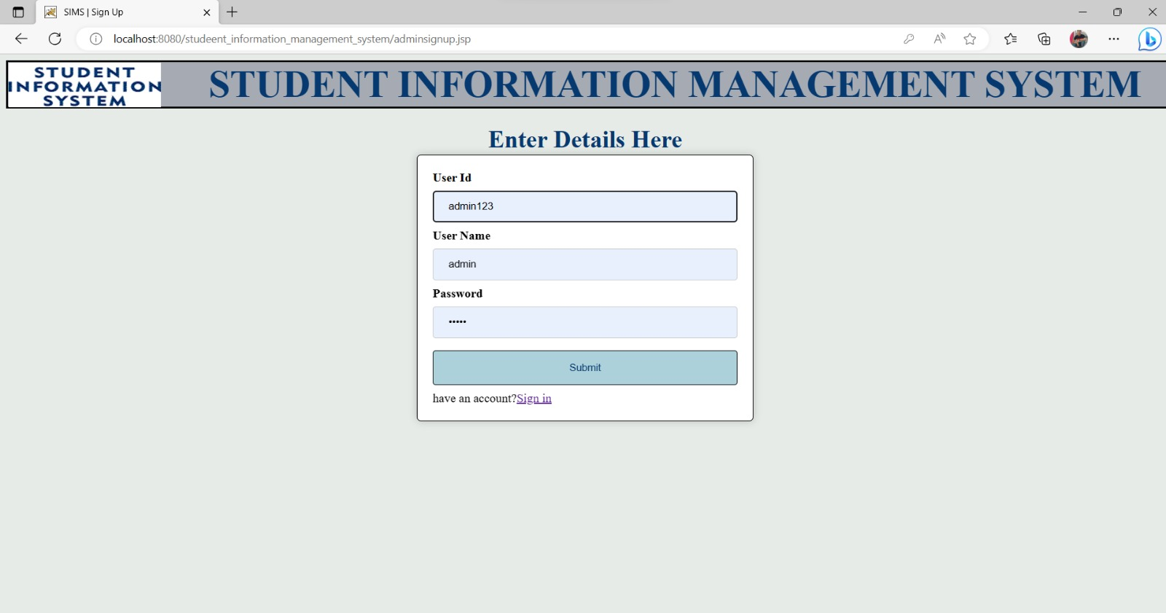

*Figure 3.3 Admin SignUp Page*

19

**3.1.4 ADMIN HOME PAGE :**

In this page Admin have two options :

* + Add New Student’s Information
  + View Student List

These two button options will lead to new different pages as per our selection. If we

don’t want to choose any option we can go back to home page by the “back to home”

button on the left.

*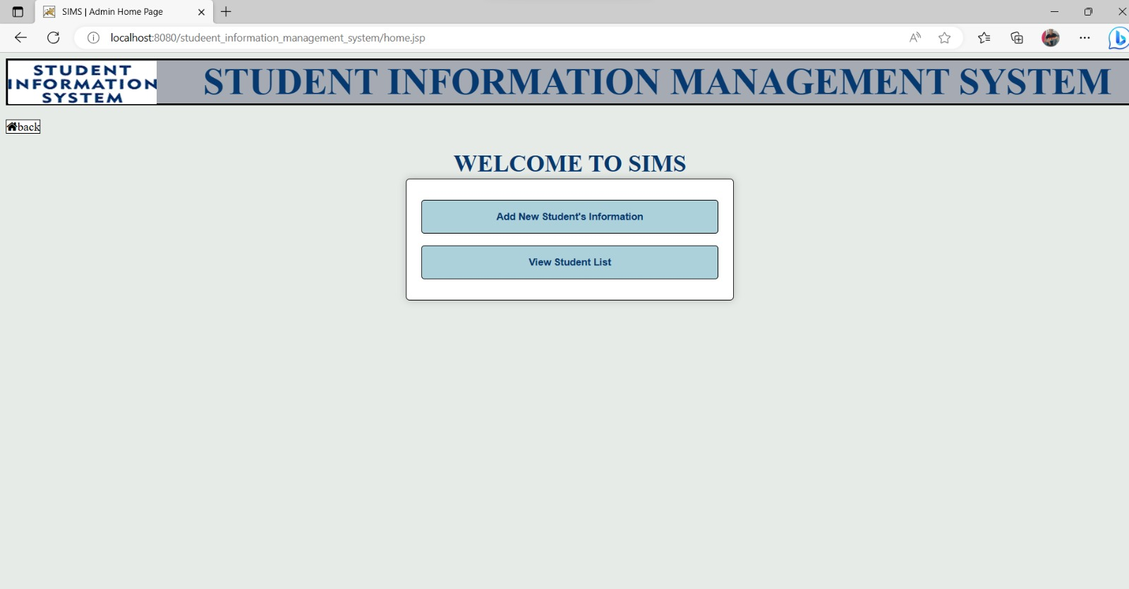Figure 3.4 Admin Home page*

* + 1. **ADD STUDENT DATA :**

In this page the Admin can add any student’s data like :

* + - Id
    - Name
    - Father’s name
    - Gender
    - D.O.B
    - Course
    - Email
    - Contact No
    - Address

20

Then there will be a submit button by use of which the information about the student is

uploaded into the database.

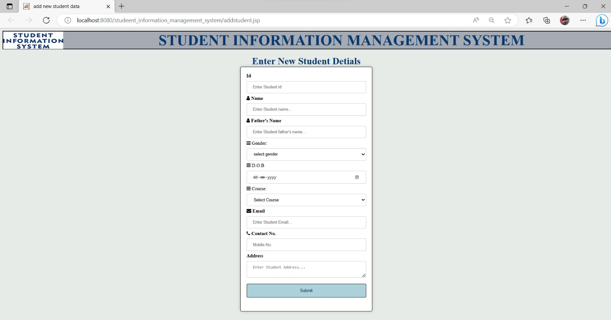

*Figure3.5 Add Student Data Page*

**3.1.6 VIEW STUDENT LIST:**

In this page, list of all students that are registered by an admin are shown with all of their details. In this page we have two buttons :

* “Delete” to delete that student’s records.
* “Edit” to edit that student’s record.

Deleting a student will delete that student’s data, while edit button will leads to a new page .

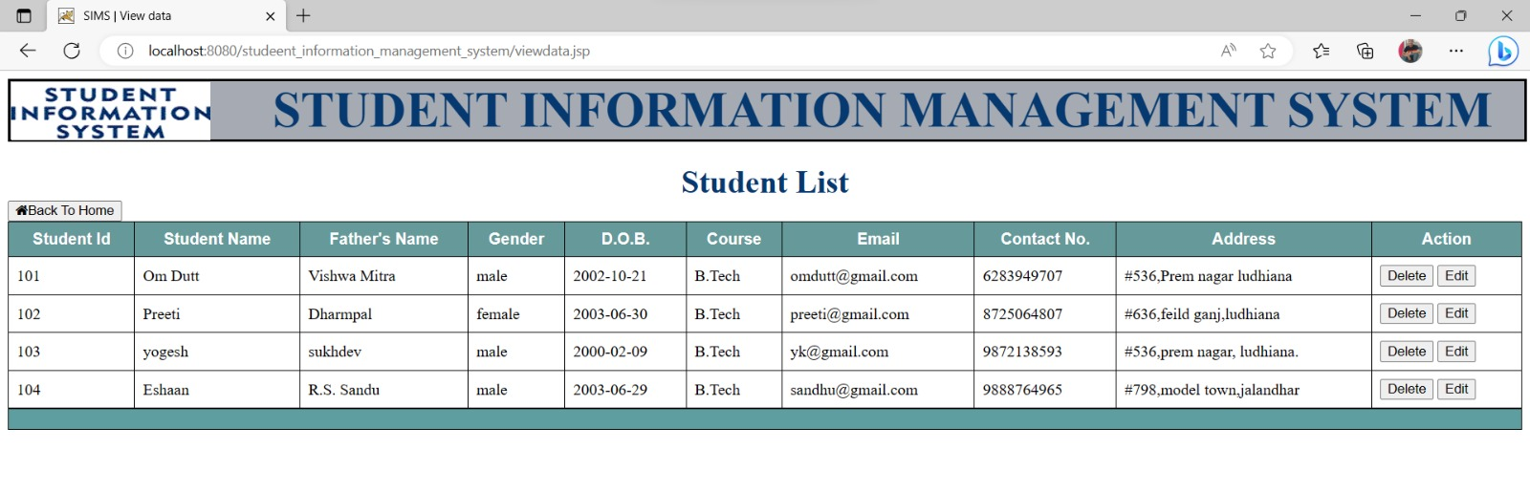

*Figure 3.6 View Data Page*

21

**3.1.7 EDIT STUDENT DATA :**

In this page Admin can edit the information about student and update the changes.

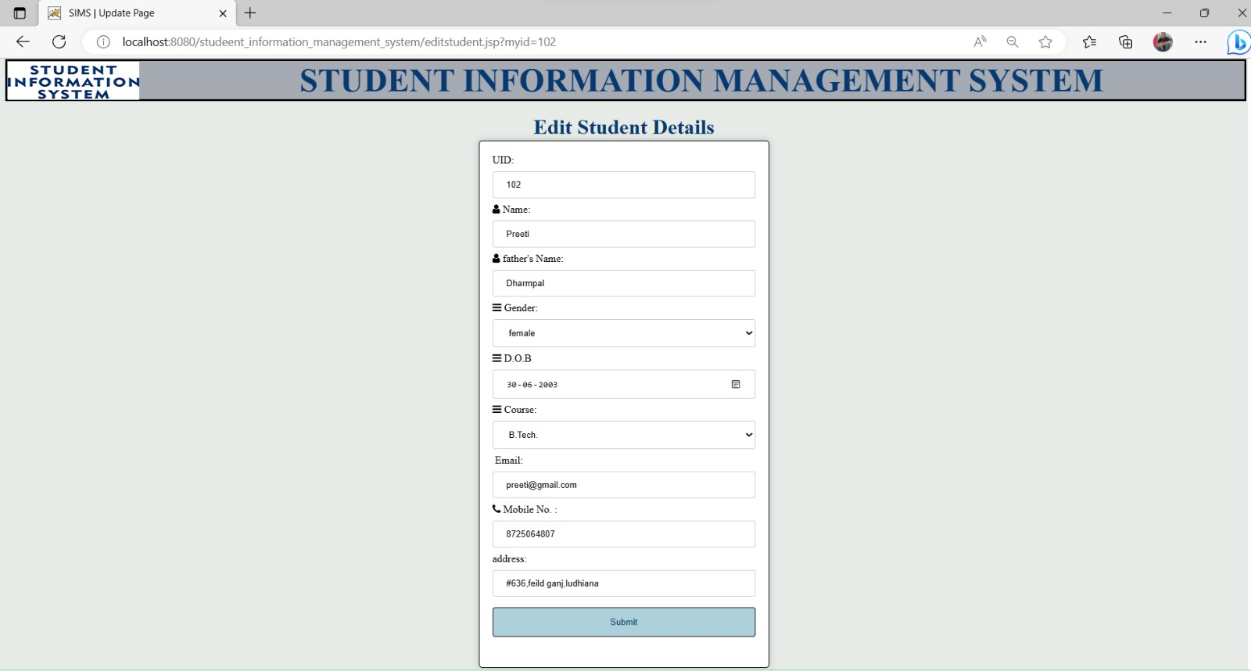

*Figure 3.7 Edit Student Page*

**3.1.8 STUDENT LOGIN PAGE :**

This page is for students which are added by an Admin. A student can Login with their Student Id and Email .

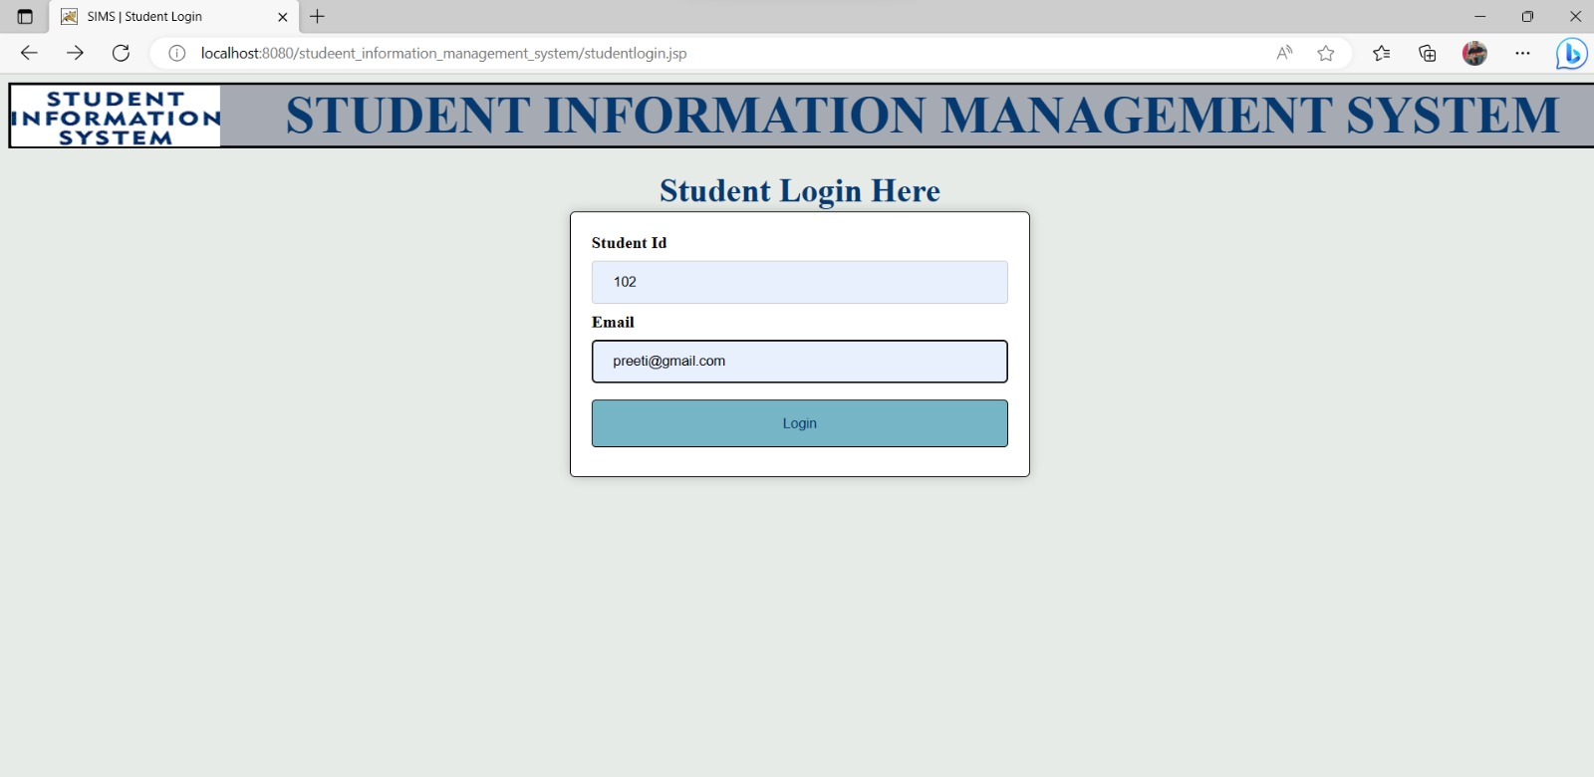

*Figure 3.8 Student Login Page*

22

* + 1. **STUDENT INFORMATION PAGE :**

After the student login to sims, he/she gets the display about their details. In this page there is an attached print option by which student is able to print their information if they want to. There is another option to go back to home page.

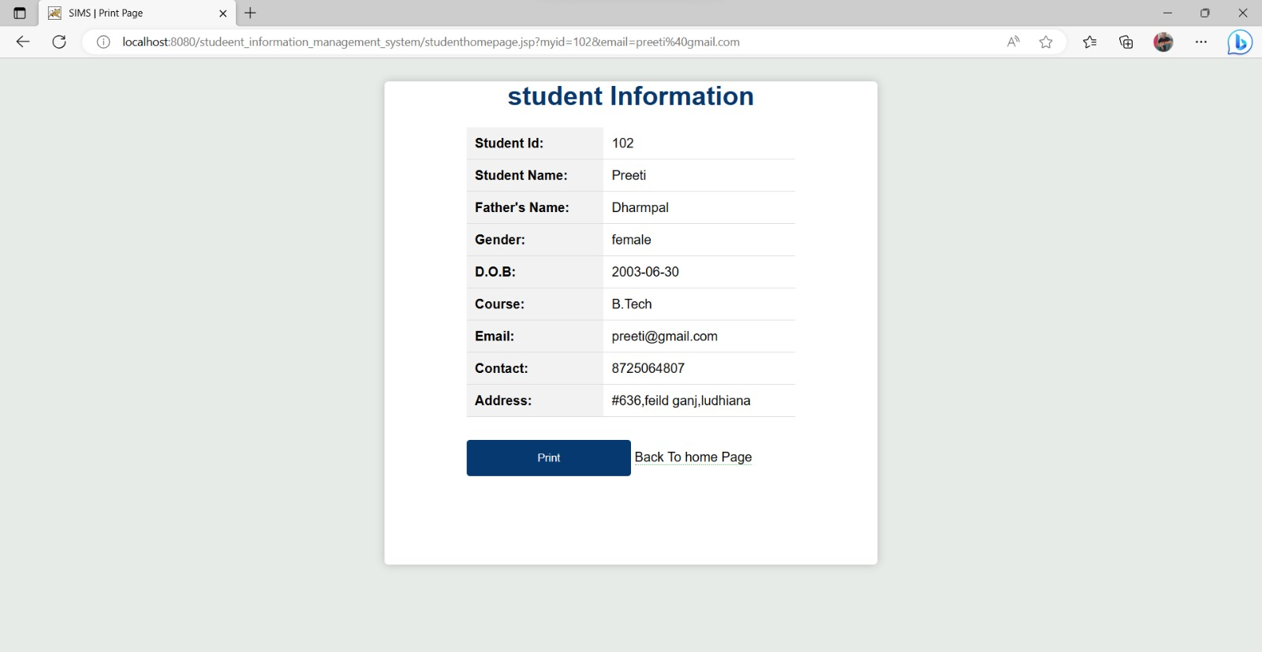

*Figure 3.9 Student Information Page*

**3.1.10 STUDENT TABLE IN DATABASE :**

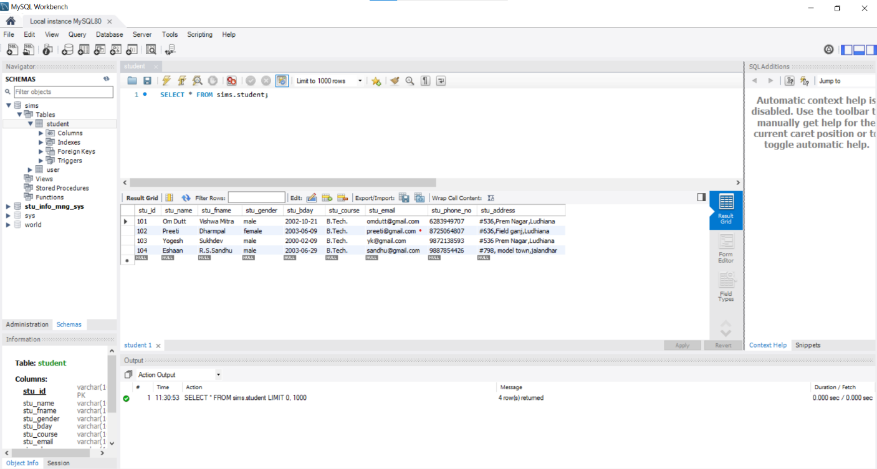

*Figure 3.10 Student database table*

23

* + 1. **USER TABLE IN DATABASE :**

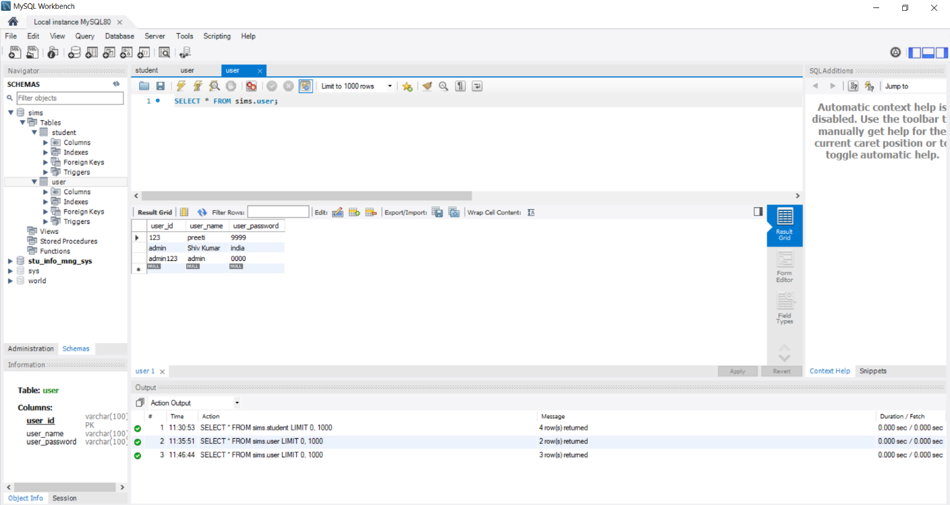

*Figure 3.11 User database table*

24

# **CHAPTER 4 – CONCLUSION AND FUTURE SCOPE**

## **CONCLUSION**

The project titled **Student Information Management System** is like a game which is designed in Java. In this system, an Admin can enter a students’s details and student can see his details.This software is developed with scalability in mind. Additional modules can be easily added when necessary.

The software is developed with a modular approach. All modules in the system have been tested with valid data and everything works successfully.

The project has been completed successfully with the maximum satisfaction . The constraints are met and overcome successfully. The system is designed as it was decided in the design phase. The project gives a good idea on developing a full-fledged application satisfying the user requirements.

The system is very flexible and versatile. This software has a user-friendly screen that enables the user to use it without any inconvenience. Validation checks induced have greatly reduced errors. Provisions have been made to upgrade the software. The application has been tested with live data and has provided a successful result. Hence the software has proved to work efficiently.

The lessons learnt after developing this project are as follows:

1. Before developing any project the requirement should be made well clear so that after developing it the programmer does not have to change it.
2. Time and Cost are those constraints, which are never told but always accounted for.
3. Project should be error free and made I such a way so that modifications can be done in future.
4. A professional should have a vision to see beyond requirements.
5. User should be given proper training about how to use the project.

25

## **FUTURE SCOPE**

The future scope for a Student Information Management System (SIMS) is likely to continue expanding and evolving due to advancements in technology and changing educational requirements. Here are some future directions for SIMS that can be included :

1. **FACULTY LOGIN:** We can give access of SIMS to the faculty members so that they can also have access to student’s data. They can manage students internal and attendance on it .
2. **STUDENT LOGIN:** We give more authorities to the students like fee payment, fine payment . student can also check their attendance and internal marks .

26

# **REFERENCE**

**Books & Online Tutorials**

* The online Java tutorial @ http://docs.oracle.com/javase/tutorial/. (The authoritative source.)
* Paul Deitel and Harvey Deitel, "Java How to Program", 9th ed, 2011. (A comprehensive reference for programmers.)
* Y. Daniel Liang, "Introduction to Java Programming '', 9th ed, 2012. (Good textbook for undergraduate Java courses.)
* Bruce Eckel, "Thinking in Java", 4th ed, 2007. (Great book but has not been updated?!)

27